Quiz_Lecture06

Name：刘承奇 Student ID：2018533249

By the formula in 4.3.2 Computations for LDA, *The Elements of statistic learning,* page 132:



For the new covariance matrix after the data sphering:

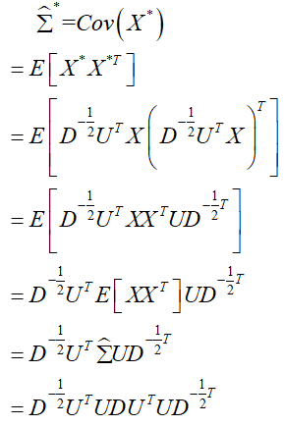

(Because U have unit length, )



(Because D is a diagonal matrix)

So, data sphering makes 